PROJECT NAME: EAZYCREDIT
Corrections:
Website Changes:
Desktop View:
- On First Slider, Slider background color needs to be set as per Figma Color theme.
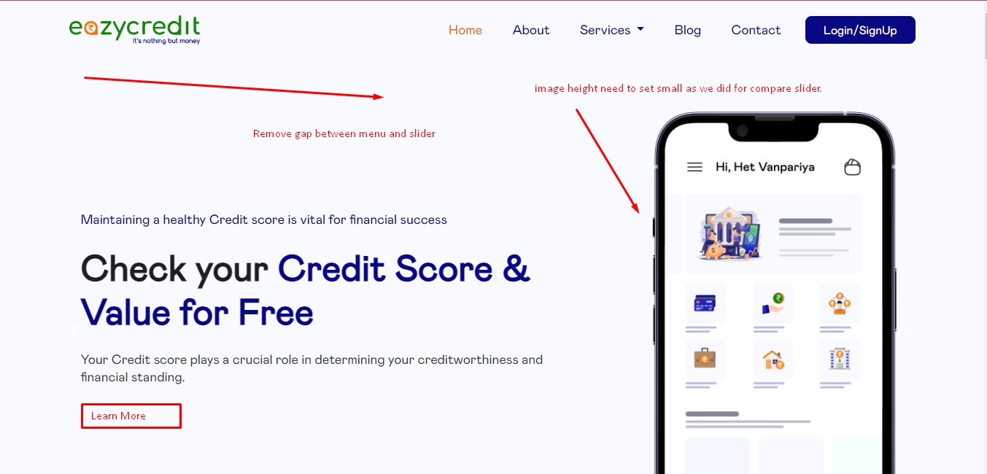
Remove gap from this also.
And right side image is looking large. Set image height as we did for compare slider. Put Learn More Button after Description of Slider. And redirect to sign up page. Make header color as white background
Mobile View:
On mobile view hide slider description. Slider title and sub title and learn more button only appear with its image. Apply background color same as Figma. Make header color as white background.
For Mobile View Check Reference website as https://eazycredit.in/

- After Sign Up User redirect to edit profile page where he will update his profile accordingly.
- Credit card and Loans Section

Desktop View:
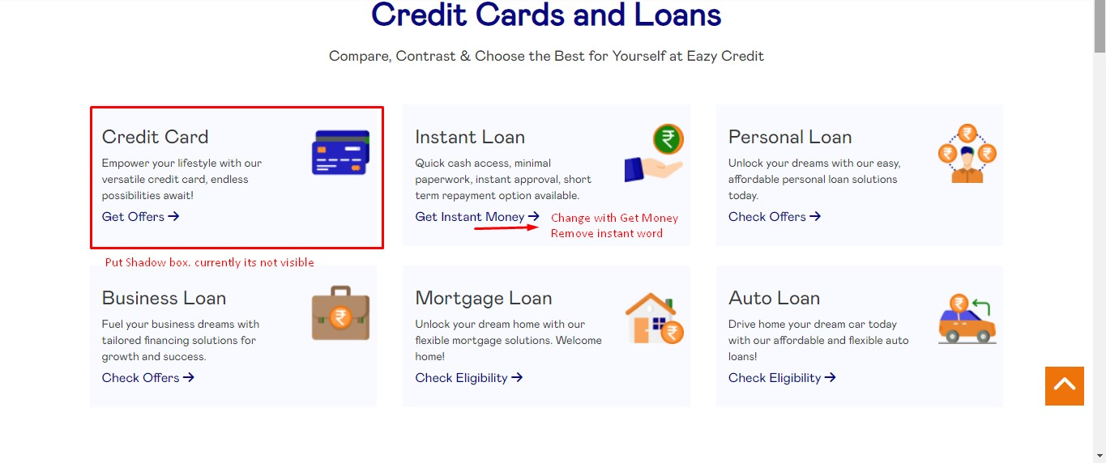
Put shadow box in clear way and change wording of get instant money to Get Money.
Mobile View:
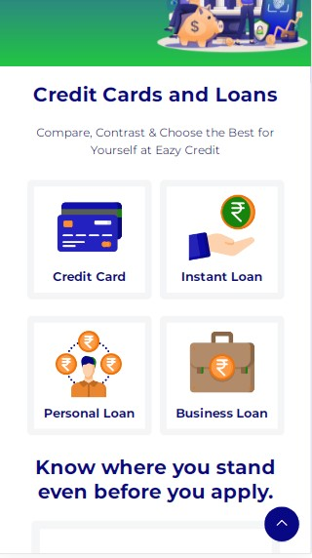
This type of icon need to show with same left and right and center margin with shadow box. All 6 tabs should be in same size with all four sides. Add shadow for the same.

- Credit score section
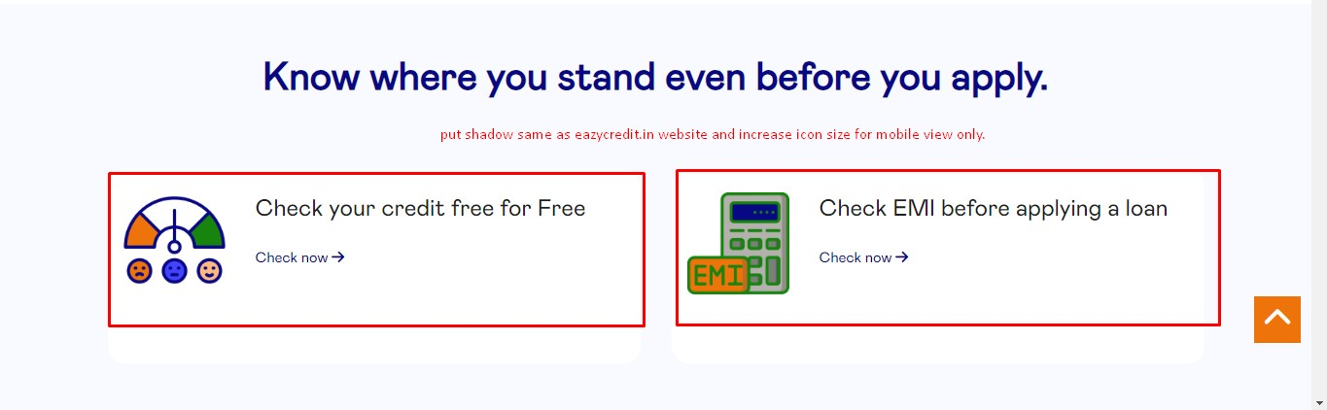

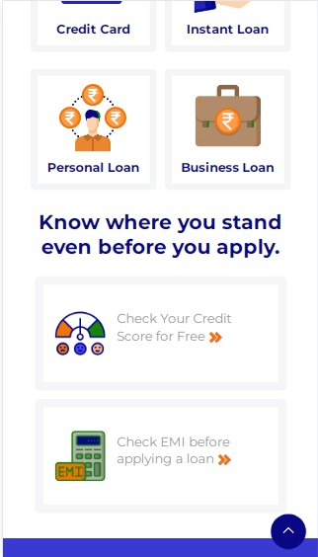

- Featured offers from our partners section
Keep content till as Discover exceptional offers that reflect our commitment
Remove further content.
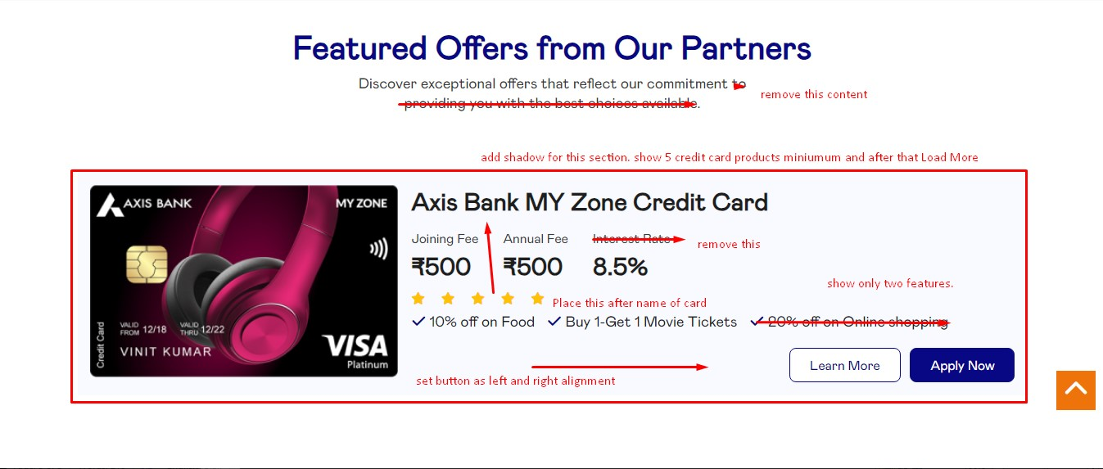

- Why To Choose Us Section
Desktop View:
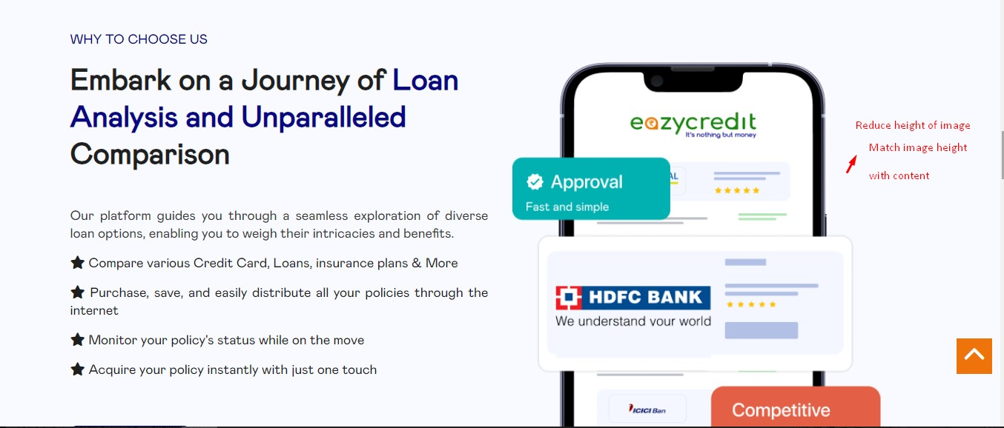

Mobile View;
View Should be as follows:
Why To Choose us?
Embark Title
Image
Description
More About us Button.

- Join us today Section
Desktop View:
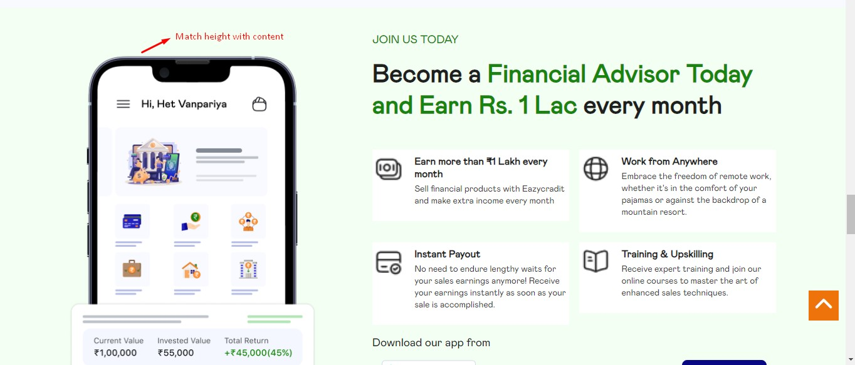
Mobile View:
Content sequence should be as
Join us today
Become title
Image
Description
Button

- Our Financial Partner Section:
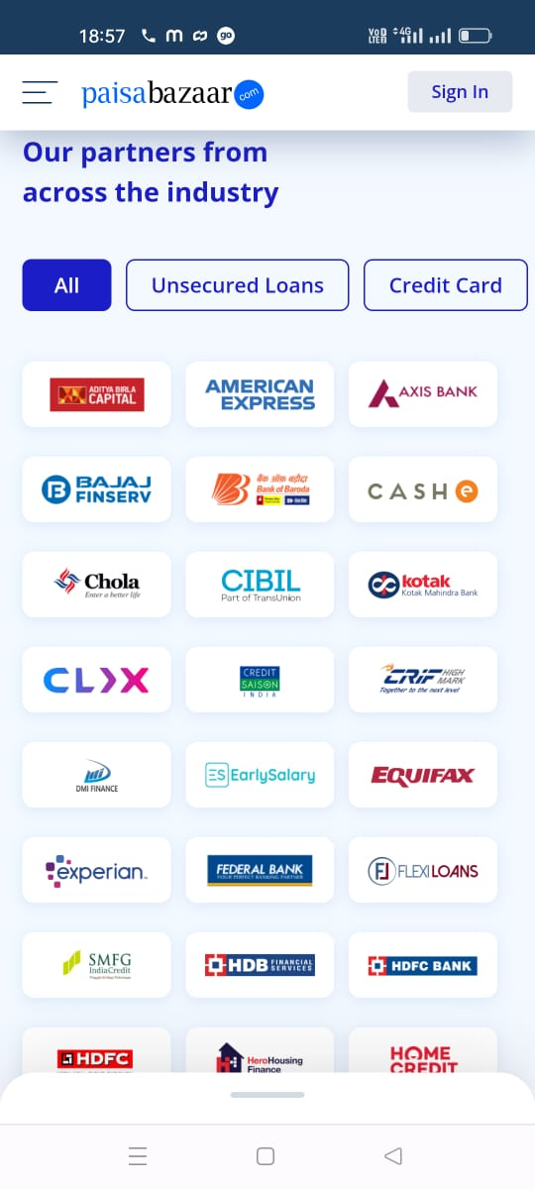
In Mobile view: 3 row and 5 coloumn need to be display only.
For desktop view this type of looks needed. This section need to come after blog section.
- Blog section:
3 blogs on one row and view more button redirect to blog page.
- Footer Section
Refer https://www.paisabazaar.com/ same type footer they needed. For mobile view footer logo looks very big. Keep same size logo as paisabazar website have in mobile view. Same type of mobile view footer they needed for mobile view footer.
Page : Partner Page
- Unlock Extra Section
Keep 2 Cards on left and keep 2 cards on right side. As left and right side with same height and width with same margine
For mobile view: its coming one by one.
- Start earning with 3 easy steps
For Mobile view set image after title and then show steps content accordingly.
- Products You can sell on eazycredits section
Check Figma design and add shadow for this Services box in proper format.
For mobile view keep two section on single row.
- Our Financial Partner: Same type of homepage content need to set. We already gave changes for homepage. Same changes here need to be done.
- Footer section need to be change as per homepage changes.

Need to add separate pages for Instant Loan, Personal Loan, Business Loan, Mortage Loan, Auto loan.
Same Loan template need to be use for this Loan Pages.

Page Name: Credit Card
- Apply your card Today Section
Loan Minimum 10 to 15 card List.
Show Card list as we did same for homepage correction. Same way design needed here. After 10 cards view more card button will be there.
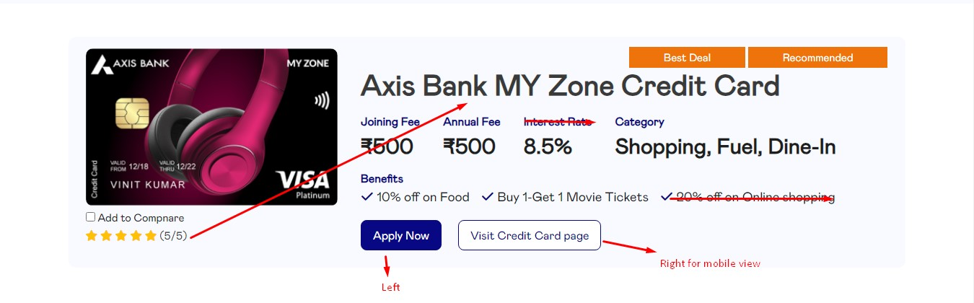
Based on Credit score selection bottom cards need to show and hide automatically.

For Credit card details Page refer below template for Details page for all products.

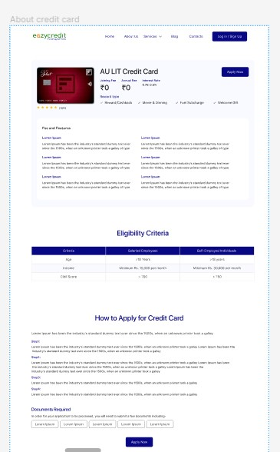

Remove our credit card like no other section from this design.

